Chapter 11, Solution 17.

We find 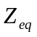 at terminals a-b following Fig. (a).

-j10 
40 
30 
j20 
(a)
a
b

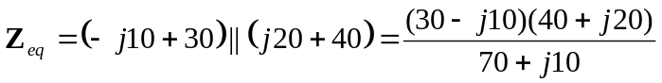 = 20 Ω = Z_{L}

We obtain 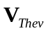 from Fig. (b).
-j10 
40 
30 
j20 
(b)
j5 A
+ V_{Thev} 
I₂
I₁

Using current division,
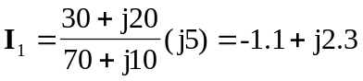
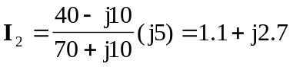

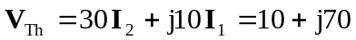

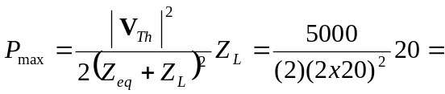 31.25 W

